# Task-1

## Question

## Solution Screenshots

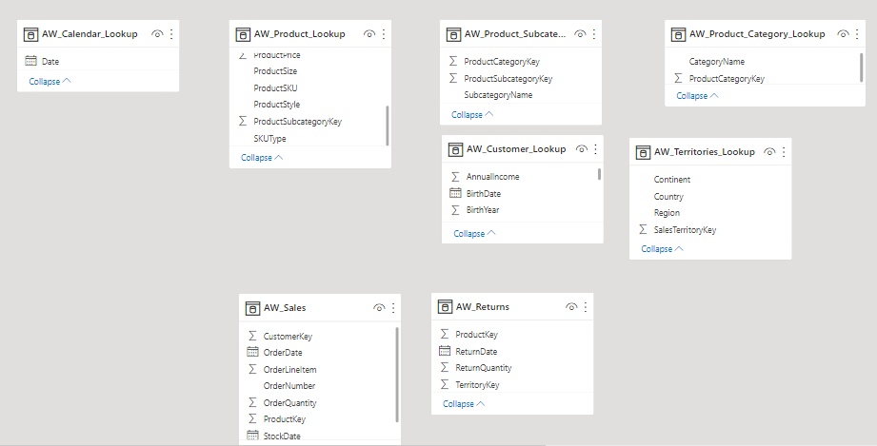

# Task-2

## Question

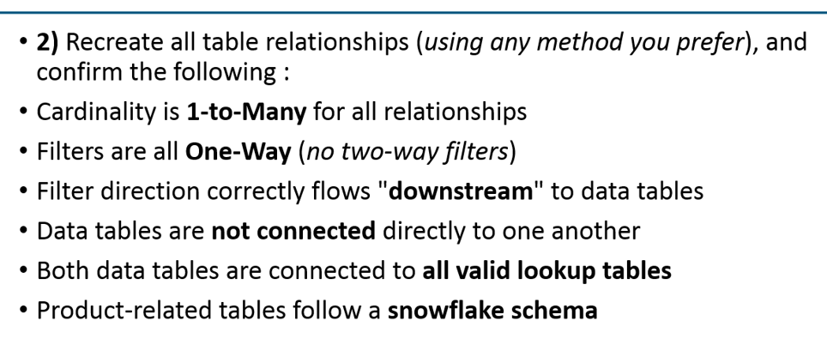

## Solution Screenshot

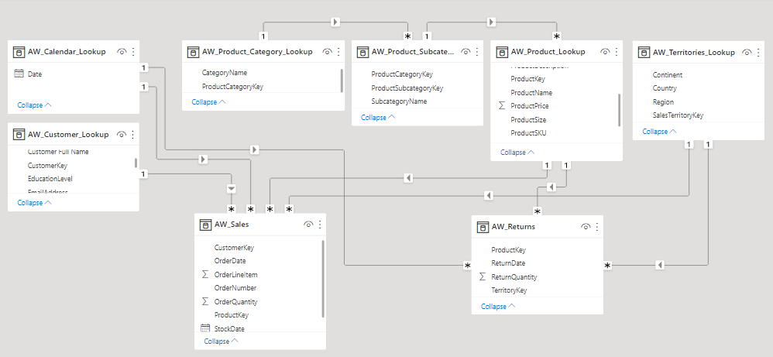

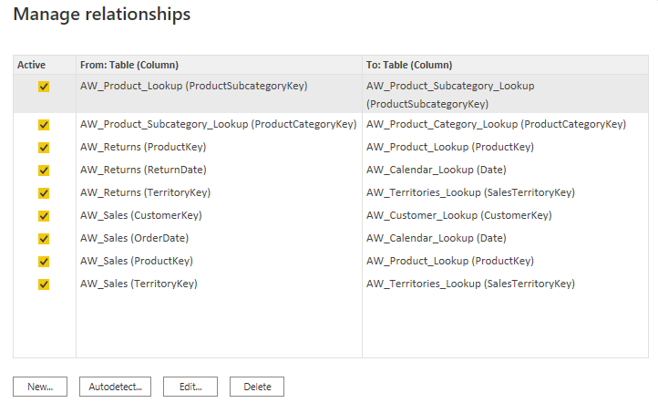

# Task-3

## Question

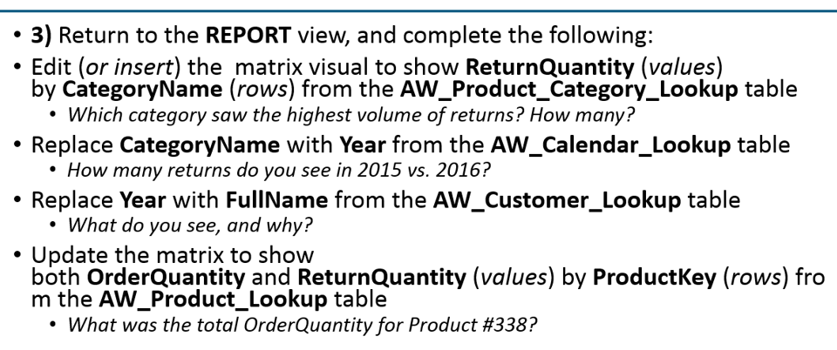

## Solution Screenshot

Accessories has highest number of returns. It is **1130**.

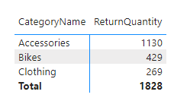

There are 86 returns in 2015 vs 770 in 2016.

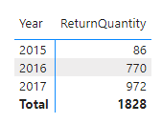

We see the Total Sum of Return Quantity (same value) for each Customer because there is no relationship between Customer Table and Returns Table.

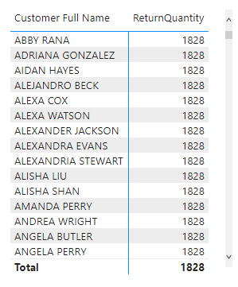

Total Order Quantity for Product Key 338 is 50.

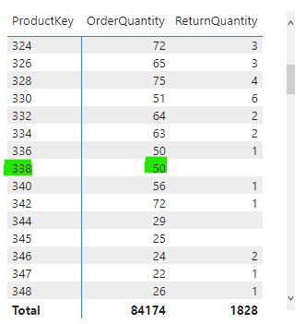

# Task-4

## Question

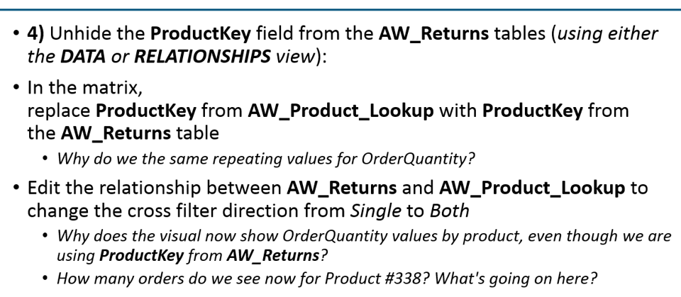

## Solution Screenshot

The Order Quantity is same now because there is no direct relationship between two facts table Sales and Returns. As the filter direction is single from Product Lookup Table to Returns Fact Table so selecting Product Key from Returns table does not filter the Order Quantity from Sales table based on product key.

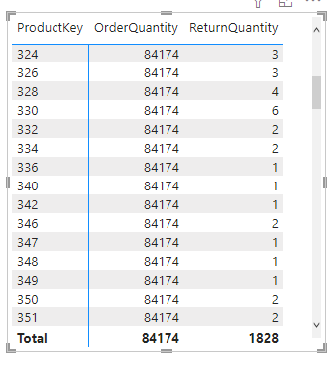

Now it filters the Order Quantity from Sales table based on Product Key in Returns Table. Because there are not returns for Product 338 so we don’t see the record for Product Key 338 in Matrix now.

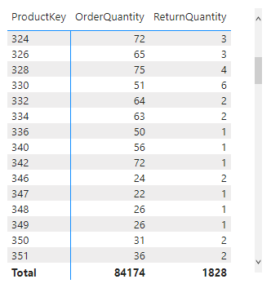

# Task-5

## Question

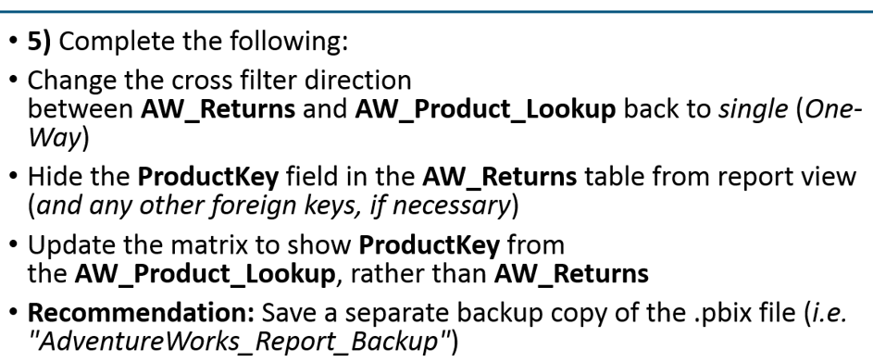

## Solution Screenshot

